DAY 26: Investigate SSH Brute Force Attack
Summary: Today, I received some alerts from the Kibana Interface. I will investigate <place holder>
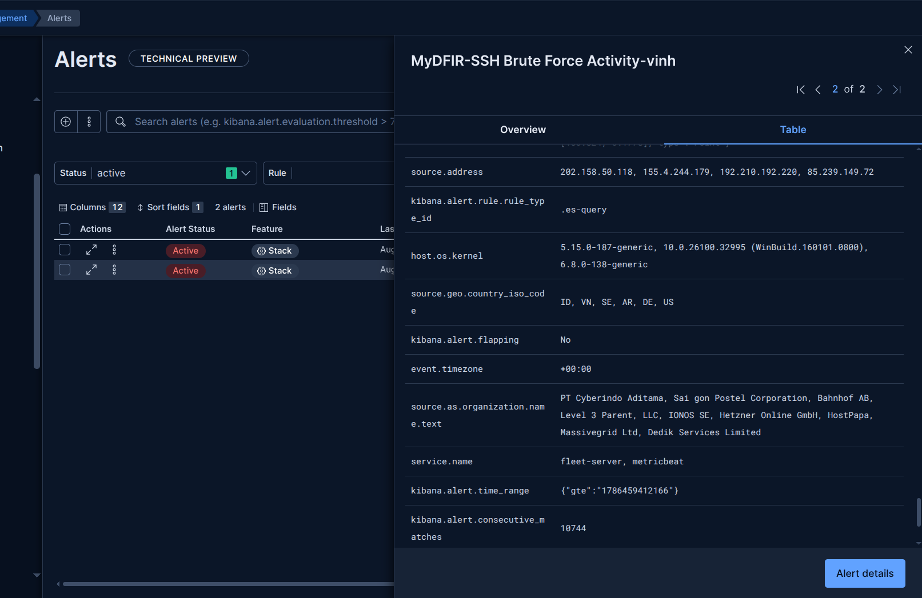
Figure 1: Alerts are triggered by SSH Brute Force Detection Rule
Brute Force Investigation List
- Is this ip known to perform brute force activity?
- Any other users affected by this ip?
- Were any of them successful?
- If so, what activity occurred after the successful login?
To answer the questions above, I’ll start the investigation by validating the alerts to extract important fields. Then, I’ll check the source IP against threat intelligence platforms and correlate it with other related activities.
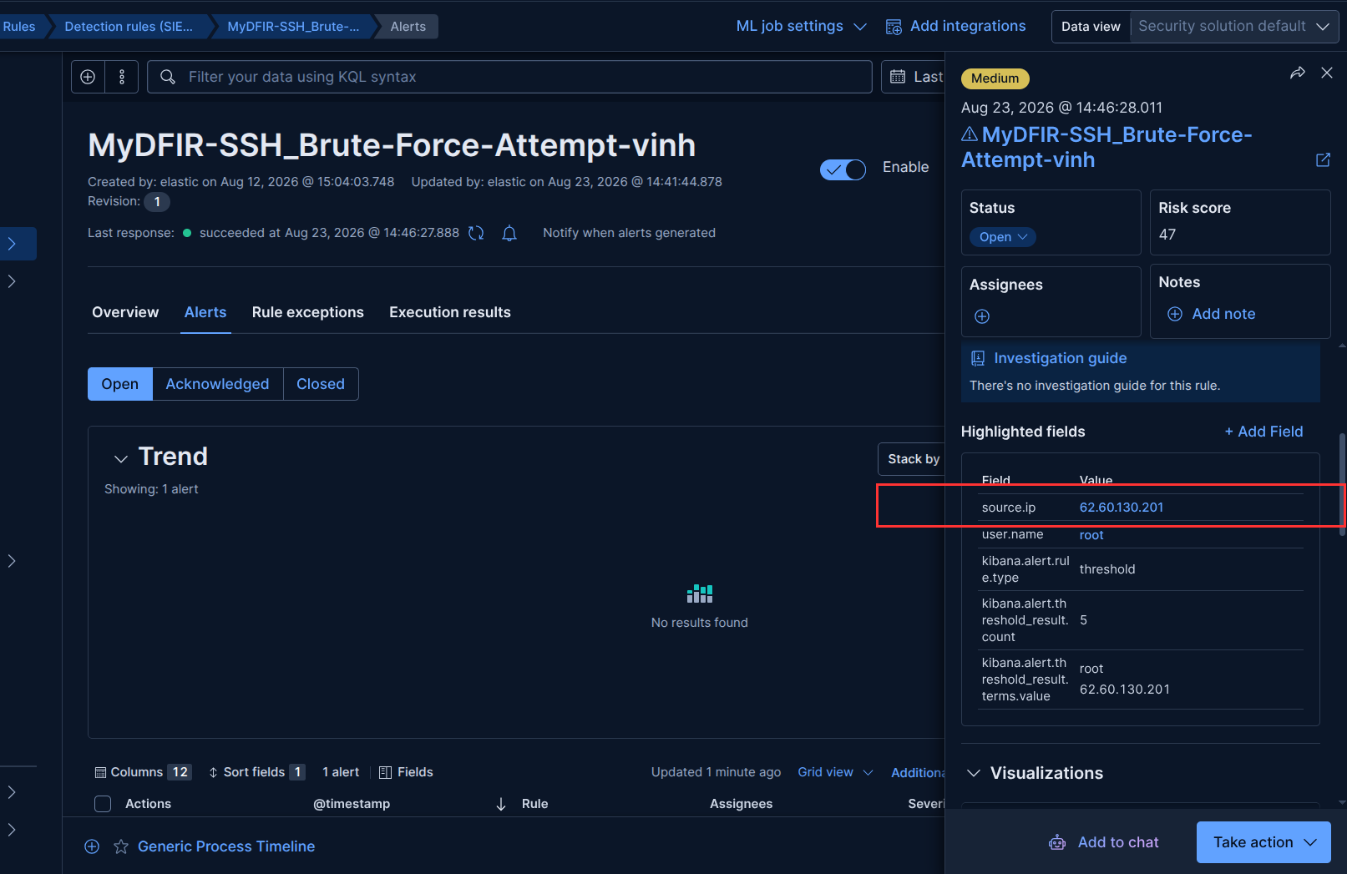
Figure 2: An SSH brute force alert
As shown in figure 2, the value of source.ip field is "62.60.130.201". I'm gonna check this value against the AbuseIPDB. AbuseIPDB provides a repository where security professionals can check or report IP addresses linked to malicious behavior [1].
I’ll paste that ip into search bar of AbuseIPDB page:
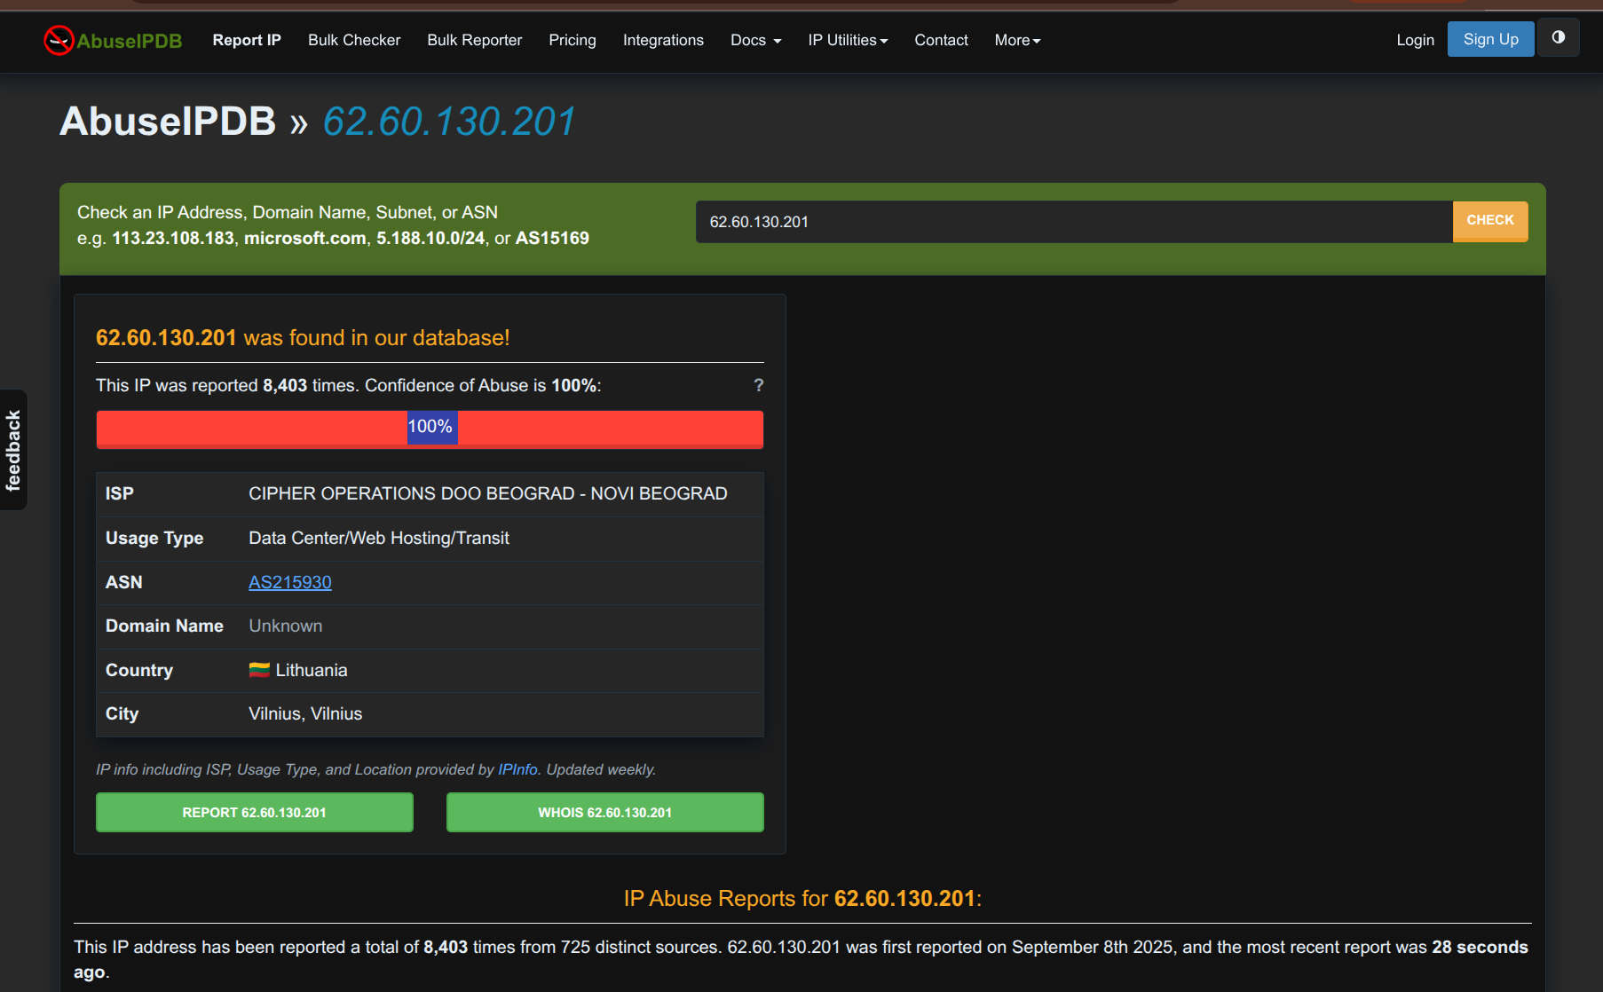
Figure 3: Search result for 62.60.130.201 on AbuseIPDB
As you can see, the IP address has been marked as 100% malicious with 8,403 related reports. The IP address is located in Lithuania, the page also provides the ISP name of that ip. Scroll down to view the detailed reports associated with this IP address:
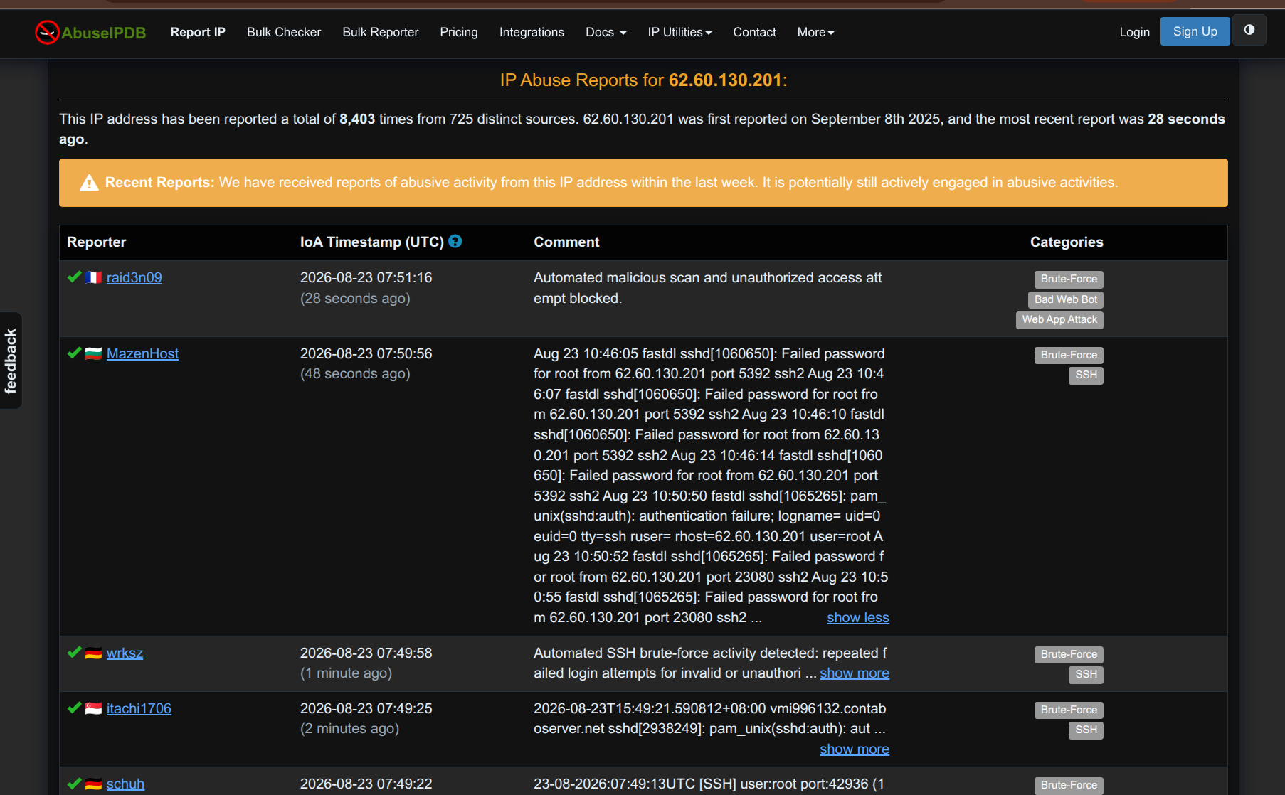
Figure 4: Specific reports for IP address 62.60.130.201
There are hundreds of reports associated with this IP, they originate from various reporters. Almost all of them are classified as Brute-Force to SSH service, which matches my case. At the top of the report table, we can see the latest reported events (just a few tens of seconds ago).

I will search for this ip on another platform - greynoise [2]:
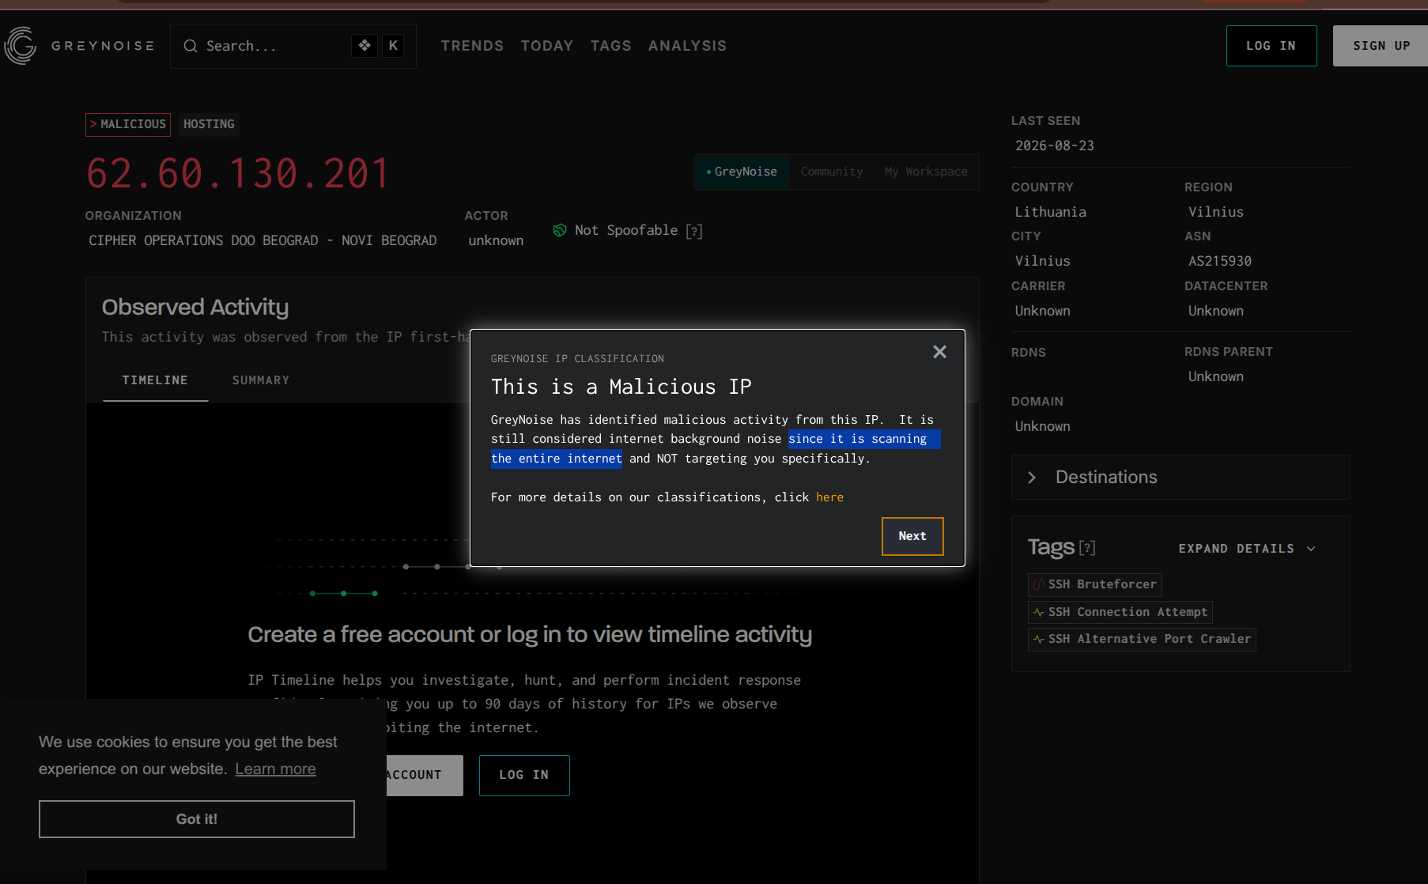
Figure 5: Search result for 62.60.130.201 on GreyNoise
The GreyNoise also identified the IP address as being associated with malicious activities. It provides similar information about the IP to what we saw in AbuseIPDB.
=> The answer for question 1 is “This ip is known malicious”

Next step, I want to identify which username the attacker is targeting. Let’s go to the Discover tab and enter this ip in the Kibana search bar. Then, click the user.name field in the left panel to view Top username values that the attacker is attempting to log in with:
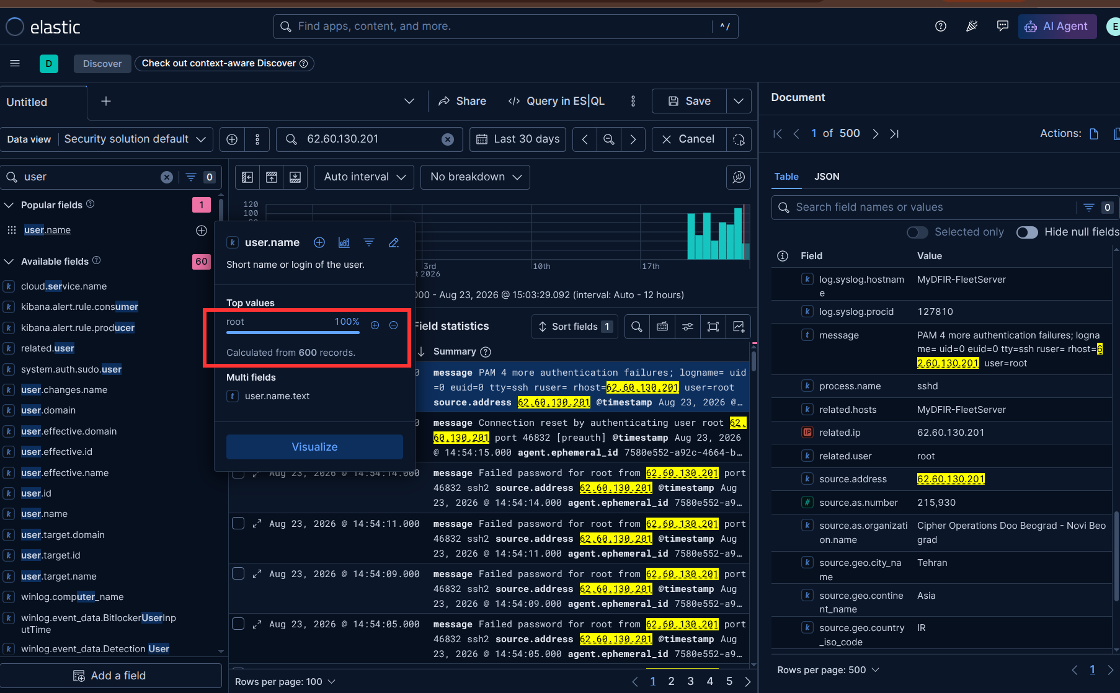
Figure 6: Target username of the attacker
As shown in Figure 6, the attacker is only targeting the root user.
=>The answer for question 2: only root user is target of attackers

Following this, I want to know are there any events that indicate the attacker log in successfully?
Now, add a term “Accepted” to look up view log in successfully events related to this IP address:
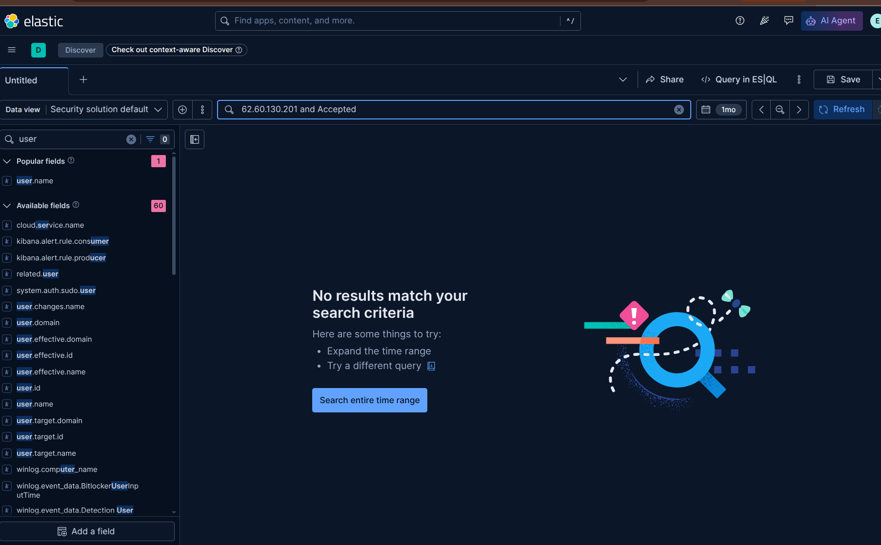
Figure 7: Searching for successful logins associated with the malicious IP

Based on the results returned by the query in figure 7, the answer to question 3 is: “None of the attempts resulted in successful login”. As a result, the answer to question 4 is: “No activity occurred after successful login”.

To upgrade my detection rule, I’ll add an action to it. In this case, I’ll configure the rule to automatically create a ticket on the osTicket I installed from the previous day whenever the rule is triggered.
Edit the rule and go to Actions tab > choose the osTicket webhook connector. In the body section, I will use the payload in the Day 25:
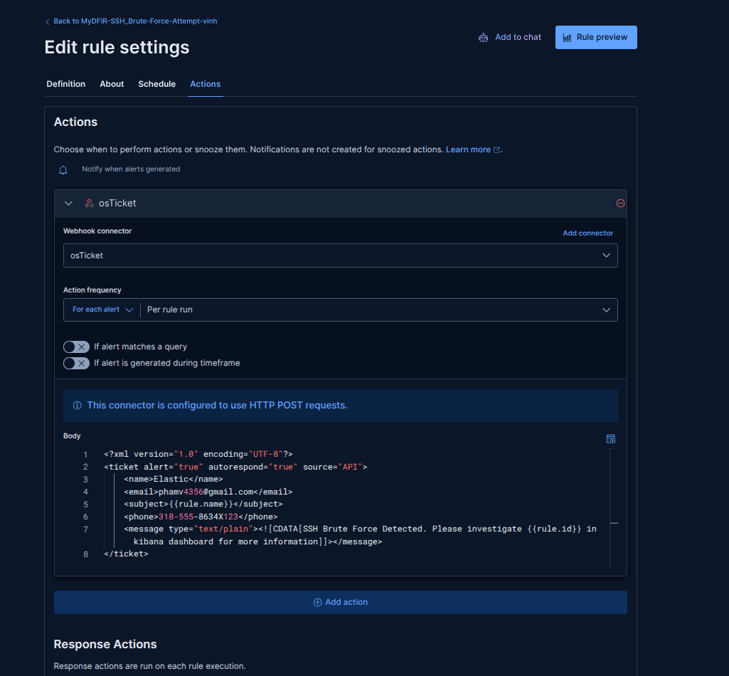
Figure 8: Adding an action to the Brute Force SSH detection rule
*Note: you can refer to payload in the link github on Day 25!
After waiting for a while, I’ll go to the osTicket page and open the Tickets tab. I should see a new ticket that was automatically created by the rule.
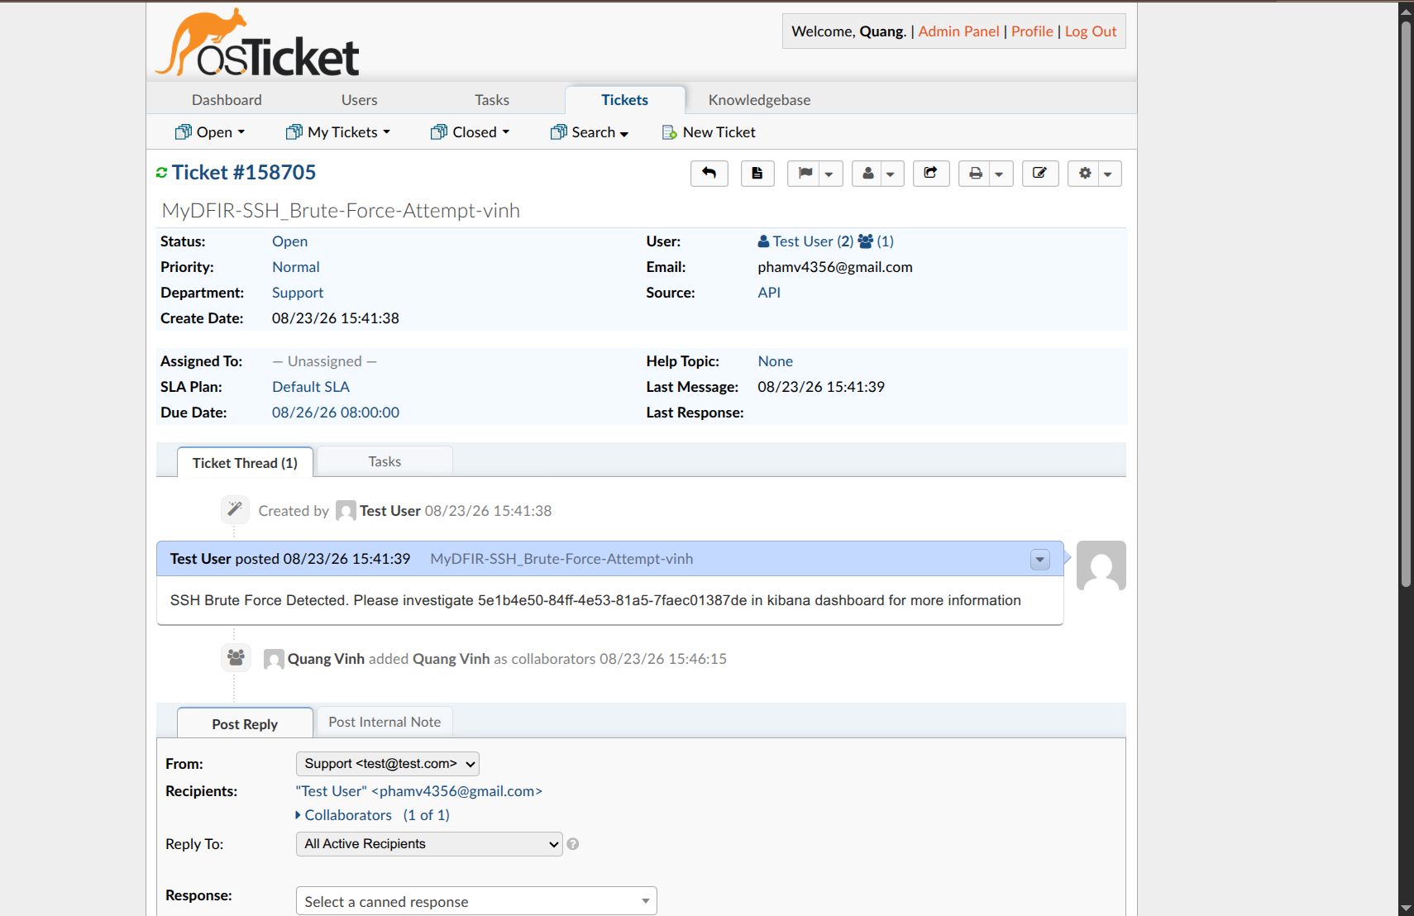
Figure 9: New ticket was triggered by the detection rule
The message displayed in the ticket is the same as the content of the message tag I configured in Figure 8. Now, let’s assume I want to make the message field more granular by adding source.ip and user.name field into it. I can custom the message as follow:

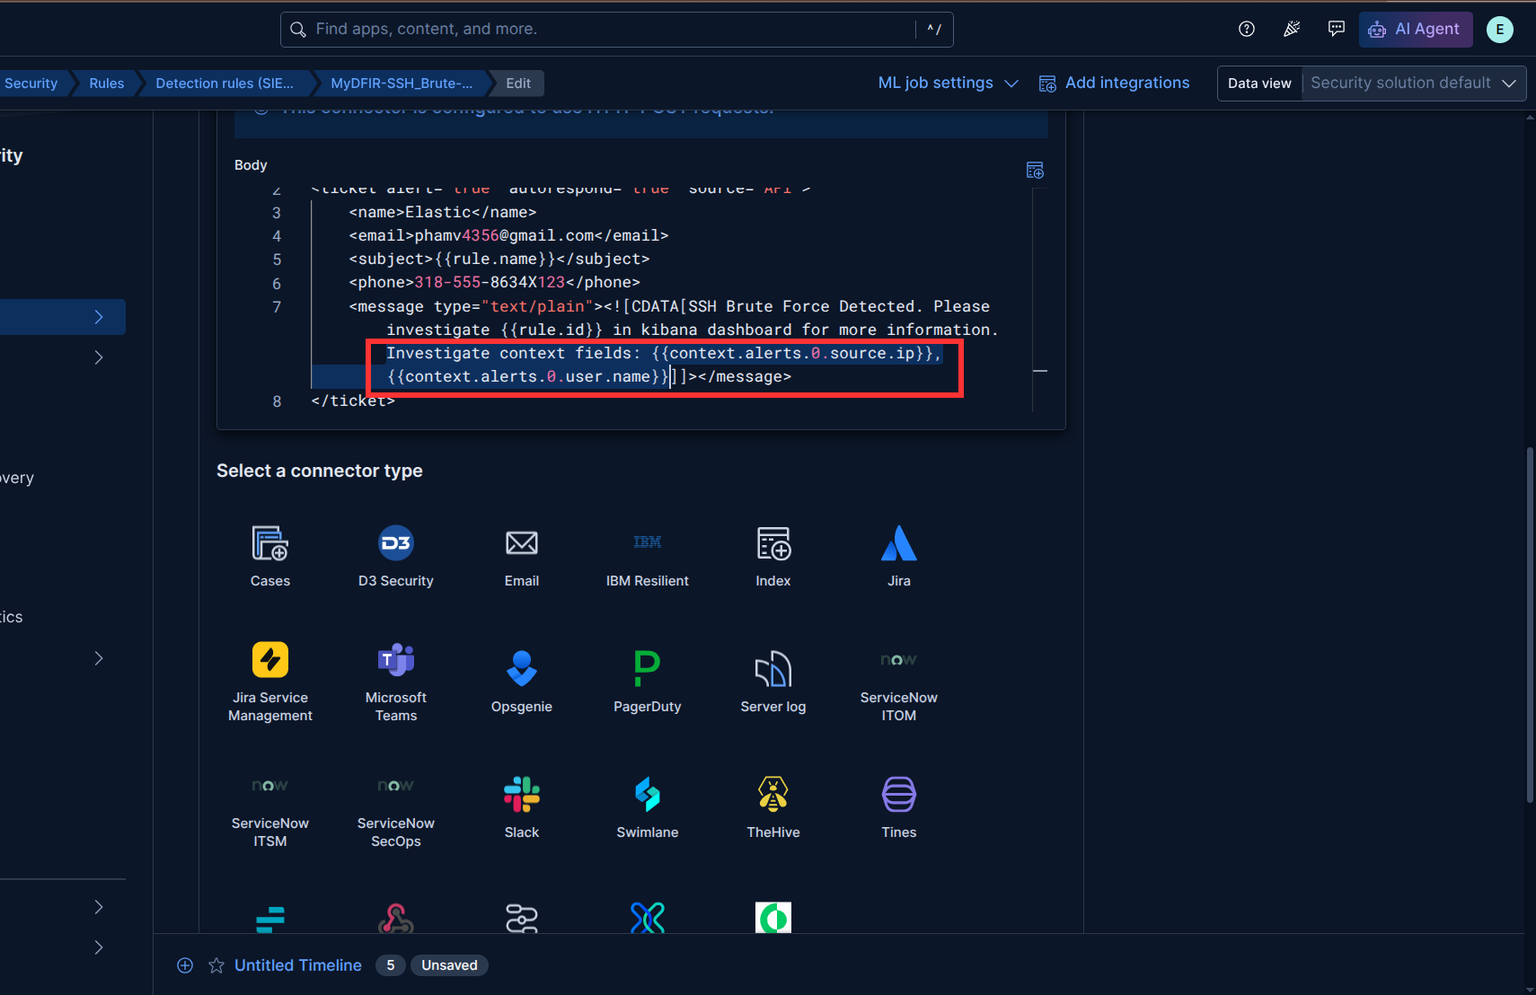
Figure 10: Adding source ip and username field to the message tag
I will perform brute force attack using Hydra to boost the ticket creation process instead of waiting for a real attack:
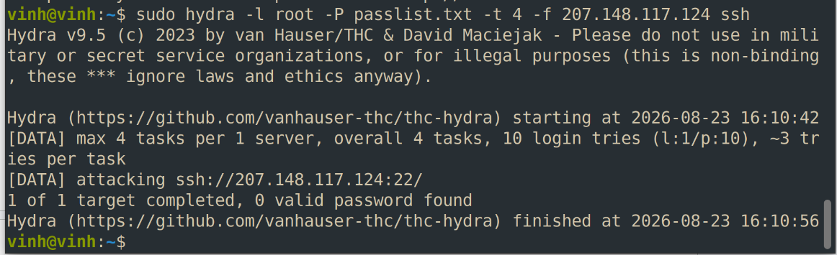
Figure 11: Using Hydra to simulate brute-force attack
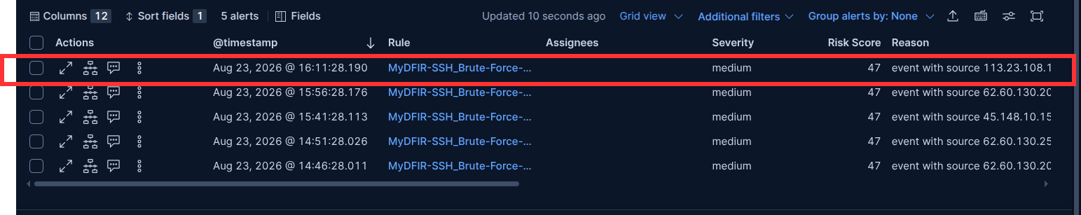
Figure 12: Alerts for SSH Brute Force attacks
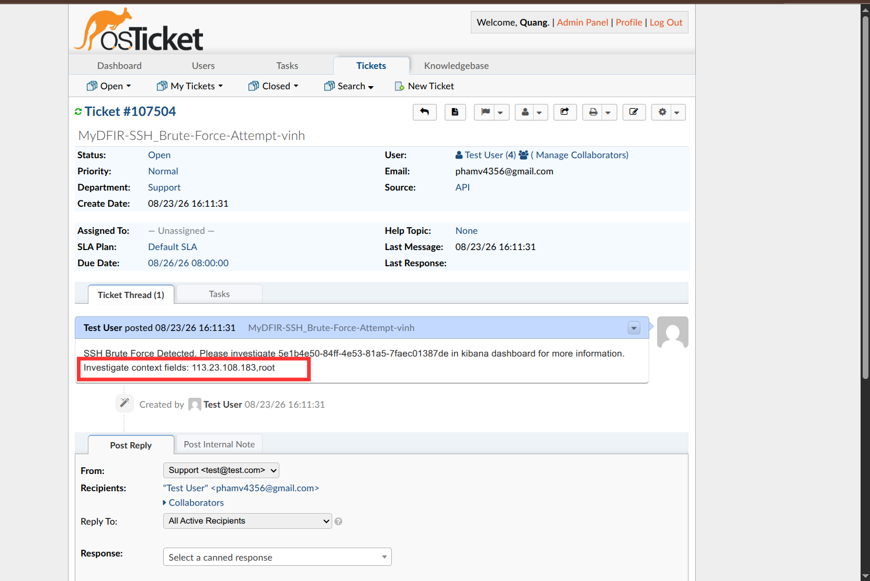
Figure 13: Source IP and Username is displayed to the message
Now, you can see the source IP address and username displayed in the message of the ticket.

Overall, this is common and required format to investigate easier

Additionally, you can add other information like Computer: <Computer name> (I can’t remember the exact field that holds this value) to know what computer in the network is compromised. If you want to include an URL linking directly to the rule for easier investigation, especially when you have many detection rules, you can add this variable: {{rule.url}}.

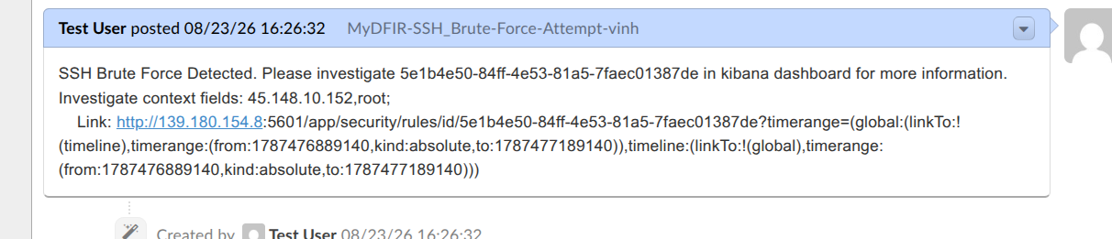
Figure 14: The message after adding {{rule.url}} field

Follow the link will lead to this page:
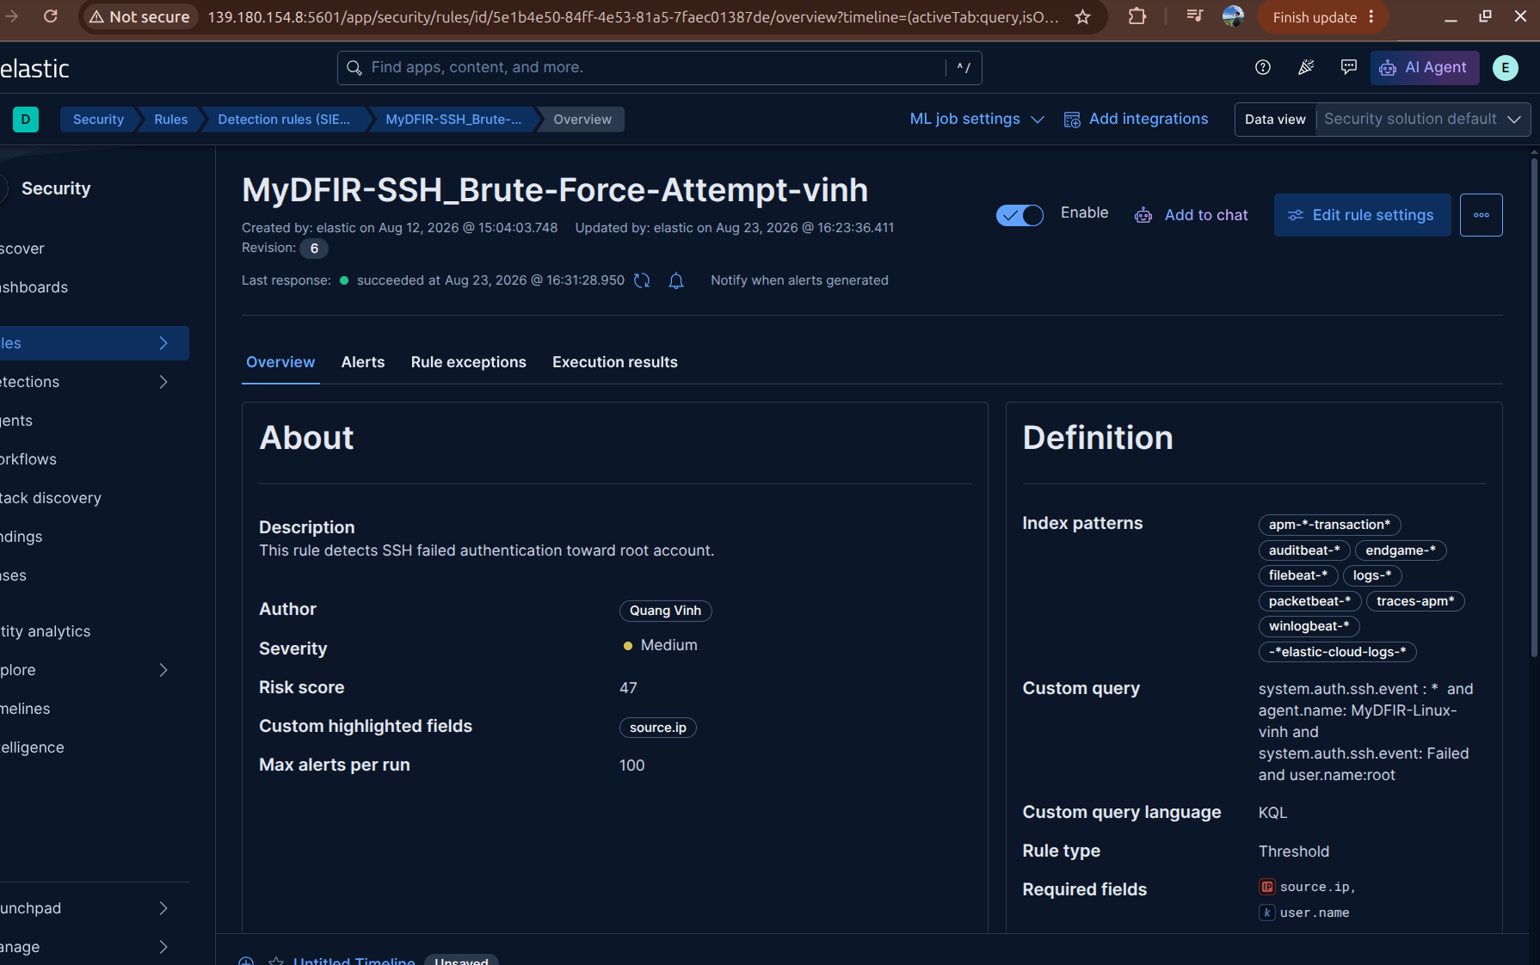
Figure 15: The rule link to the URL in a ticket

Bonus (Optional): Add a timeline to investigate

REFERENCES:
[1] https://www.abuseipdb.com/
[2] Greynoise: https://viz.greynoise.io/?_ga=2.107652870.506752464.1787471695-2013178618.1787471693
[3]

